**Frog Pre-Dissection Notes**

1. Read the Frog Dissection Reference
2. Answer the questions that follow the instructions (2 points each)
3. Label the frog diagrams: (10 points)
   1. Eyes
   2. Tympanic membrane or tympanum
   3. Front limbs
   4. Hind limbs
   5. Mouth
   6. Nares
   7. Webbed feet

Questions (bullet answers are fine)

1. What systems do frogs have in common with humans?
2. Why is a frog not a typical vertebrate?
3. How are frogs/amphibians different from other tetrapods?
4. What is unique about a frog's tongue (two things)?
5. How are frog nostrils/nares different from the shark's?
6. What do frogs use fat bodies for?
7. How are frog lungs different from human lungs?
8. Why don't frogs need complicated lungs?
9. What internal parts of the frog sound similar to those of a shark?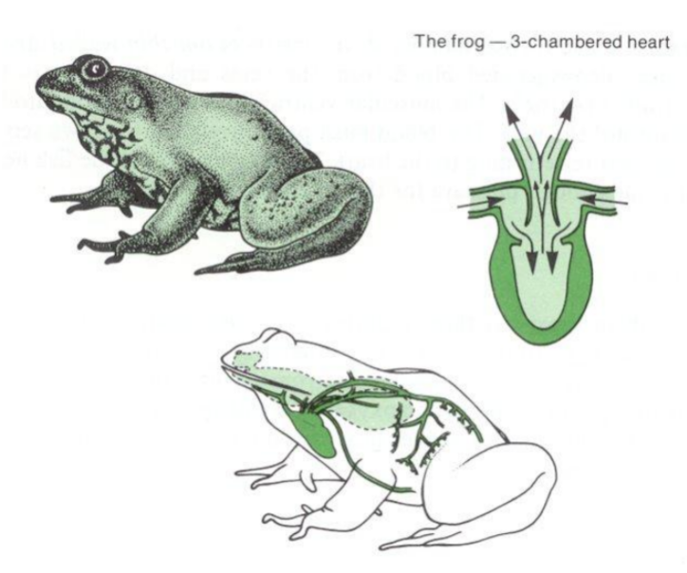
10. Which internal parts of the frog sound different from the shark's insides?